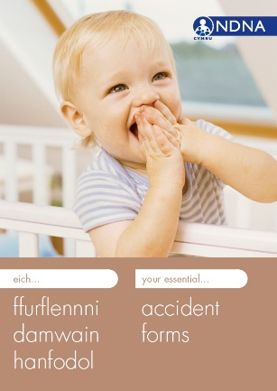

NDNA’s your essential accident forms (available in Welsh)
50 forms with carbon copies to give to parents
Discounts for bulk orders

Visit www.ndna.org.uk/publications
for more information and to order

